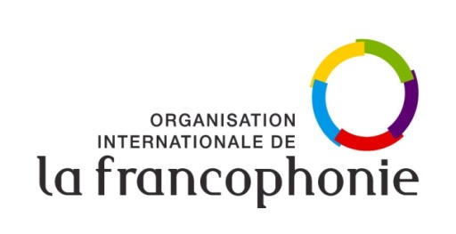

**1. What could ITU and its members and other stakeholders do to ensure that the Internet becomes more multilingual in nature and thus accessible for more of the global population ?**

Guaranteeing free expression, equitable access to knowledge and a genuine dialogue between cultures through mutual knowledge and access to a linguistic diversity of content on the Internet, multilingualism is increasingly becoming one of the pillars for the development of an inclusive digital society. Yet many languages are not sufficiently present in cyberspace due to the digital divide and the uniformizing vision of the Web giants. Citizens who don't have access to cyberspace, software tools and digital resources in their own languages risk becoming increasingly marginalized. This is why users' languages should not be an obstacle to accessing the multicultural heritage of humanity available in cyberspace.

To promote multilingualism and access to diversified cultural expressions, it is therefore necessary to support the production, accessibility and discoverability in different languages of all national and local online content, respecting the diversitý of peoples and cultures.

Multilingualism must be encouraged and defended in international digital policy negotiation and decision-making bodies. ITU could specifically contribute to the French-language training of French-speaking diplomats, experts and professionals involved in the development and implementation of digital policies, while promoting synergies between programs such as « PRIDA » (*Policy and Regulation Initiative for Digital Africa*) of ITU and « D-Clic » of OIF.

ITU could also support greater mobilization and more active participation by Francophone players in international events and conferences in the fields such as digital transformation, Internet Governance, AI for Common Goods and reducing the Digital Divide. ITU could also organize or support international events and forums to raise awareness of the importance of a multilingual Internet and share best practices in this area.

We also encourage the ITU to support the production of tools and the distribution in various languages (including French) of reference documentation produced by the ITU (guides, status reports, reports, statistical data, etc.).

ITU could enhance its collaboration with organizations such as ICANN to promote the use of internationalized domain names (IDNs) and encourage the creation of top-level domains in different languages and writing systems. It is also important to encourage research and innovation in order to create advanced linguistic technologies by integrating and developing machine translation, multilingual speech recognition and natural language processing tools.

ITU and its members and other stakeholders could also make a significant contribution to a multilingual Internet by providing technical and financial assistance to developing countries to develop Internet infrastructures and content in their local languages.

**2. What are the benefits and challenges of multilingualization of the Internet, including through universal acceptance of Internationalized Domain Names (IDNs), or the lack thereof, in terms of technical, economic, security, cultural and capacity-building?**

Multilingualization of the Internet, including through universal acceptance of Internationalized Domain Names (IDNs), offers significant benefits.

OIF is convinced that the digital environment must be developed in a way that is inclusive, responsible, supportive, healthy, safe, promotes cultural and linguistic diversity, and puts people firmly at its center. Respecting cultural and linguistic diversity in the digital environment is crucial to achieving effective connectivity for young people, women, minorities and the underprivileged.

Contrary to prevailing preconceptions that standards prevent diversity and crystallize the spirit of innovation, we believe, on the contrary, that standardization bodies can provide a means of expression for so-called “minority” languages and cultures.

It is crucial to develop and promote the use of standards in different languages, particularly those that facilitate the discoverability of national and local content or any other key area.

In terms of cultural, economic and technical benefits, for example, the following can be noted :

* Preservation of cultural and linguistic diversity on the Internet.
* Strengthening users' cultural identity through domain names in their own language (Users can choose domain names that reflect their identity or language).
* Enhanced user experience and Improved web accessibility for non-English-speaking users. (Users can access content in their preferred or native languages, creating a more personalized and engaging experience).
* Universal Acceptance (UA) of IDNs can also unlock significant economic potential by enabling more people to fully participate in the digital economy